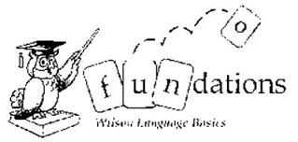

Unit 2
Week 1 -the, a, and
Week 2-is, his, of

Unit 3
Week 1- as, has, to, into
Week 2- we, she, he, be, me, or, for

Unit 4
Week 1- you, your, I, they
Week 2- was, one, said

Unit 5
Week 1- from, have, do, does

Unit 6
Week 1- are, were
Week 2- who, what, when
Week 3- where, there, here

Unit 7
Week 1- why, by, my, try
Week 2- put two
Week 3- very, too, also, some, come

Unit 8
Week1- would, could, should
Week 2- her, over, number

Unit 9
Week 1- say, says
Week 2 – see, between, each

Unit 10
Week 1- any, many
Week 2- how, now, down
Week 3- out, about, our

Unit 11
Week 1- friend, other, another
Week 2- none, nothing

Unit 12
Week 1- people, month
Week 2- been, little, own, want Week 3- Mr., Mrs.

Unit 13
Week 1- work, word, write
Week 2- their, being, first
Week 3- look, good, new

Unit 14
Week 1- water, called
Week 2- day, may, way

